1. What is a WebSocket?
A WebSocket is a communication protocol that provides full-duplex, persistent communication between a client and a server over a single TCP connection.
- Websockets allows use to open two way interactive communication session bt user brower and server.
- Websockets is avalible in almost all browsers.
Full-Duplex = Both sides can send and receive data simultaneously.
Think of it like a phone call:
- HTTP = Sending letters through mail
- WebSocket = Talking on a phone call

2. Why WebSockets Were Created
Traditional HTTP has a problem:
- Client sends request
- Server sends response
- Connection closes
If the server wants to send new data:
❌ It can't.
The client must ask again.
Example:
Client: Any new notifications?
Server: No.
Client: Any new notifications?
Server: No.
Client: Any new notifications?
Server: Yes.
This is inefficient.
WebSockets solve this by keeping the connection open.
Client ---------------- Server
Persistent Connection
Server can push data anytime

- WebSocket vs HTTP
Feature | HTTP | WebSocket
Connection | Short-lived | Persistent
Communication | Request-Response | Two-way
Real-time | Poor | Excellent
Overhead | High | Low
Notifications | Polling | Instant
Streaming | Difficult | Easy

Interview Answer (30 Seconds)
Q: How are TCP, IP, and WebSockets related?
Answer:
IP is responsible for routing packets between devices across networks. TCP sits on top of IP and provides reliable, ordered, and error-checked communication through a connection-oriented protocol. WebSocket is an application-layer protocol that runs over TCP. When a WebSocket connection is established, it first creates a TCP connection, performs an HTTP upgrade handshake, and then uses that same TCP connection for full-duplex real-time communication. Therefore, WebSocket relies on TCP's reliability and IP's routing capabilities.

Easy Memory Trick
IP = Where to send data
TCP = Make sure data arrives correctly
WebSocket = Real-time conversation using TCP
Or:
WebSocket rides on TCP
TCP rides on IP
IP rides on the network

What is Polling?
Polling is a technique where the client repeatedly asks (TCP Handshake) the server for updates at fixed intervals.
- Polling is not real time rather near to real time.
- Always we open new connection for getting new updated data from the server.
- Better alternative is websockets where we does not close the established connection
- Websockets allow us to keep open the established connection

Instead of the server sending data when something happens, the client keeps checking:
Client: Any new data?
Server: No
(wait 5 seconds)
Client: Any new data?
Server: No
(wait 5 seconds)
Client: Any new data?
Server: Yes, here it is

Real-World Example
Imagine you're waiting for exam results.
Polling is like walking to the notice board every 5 minutes and asking:
"Has the result been posted yet?"
Most of the time, the answer is:
"No."
This wastes time and effort.

Problems with Polling

1. Unnecessary Requests
Suppose an alert occurs once per hour.
With 5-second polling:
3600 / 5 = 720 requests
Only one request returns useful data.
719 requests are wasted.

2. Delayed Updates
If polling interval is:
5 seconds
and an event happens at:
12:00:01
the client may not see it until:
12:00:05
Result:
4-second delay

3. Higher Server Load
Thousands of users polling means:
10,000 users
×
1 request every 5 sec
=
2,000 requests/sec
Many requests may contain no new information.

Polling vs Long Polling vs WebSocket

Polling
Client ---> Server
Client ---> Server
Client ---> Server
Client ---> Server
Characteristics:
- Simple
- Many unnecessary requests
- Delayed updates

Long Polling
Client sends request:
Client ---> Server
Server waits until data is available:
(wait)
Then responds:
Server ---> Client
Client immediately creates a new request.
Client ---> Server
Better than polling, but still HTTP-based.

WebSocket
Single connection:
Client <-------------> Server
Server can push data instantly.
No repeated requests.
Q: What is polling?
Polling is a communication technique where a client repeatedly sends requests to a server at fixed intervals to check for new data or updates. While simple to implement, polling can generate many unnecessary requests, increase server load, and introduce delays. For real-time applications, WebSockets are usually preferred because they maintain a persistent connection and allow the server to push updates instantly.

For example, here's Polling in Python using requests:
import requests
import time
while True:
response = requests.get("http://localhost:8000/alerts")
if response.status_code == 200:
data = response.json()
print("Server Response:", data)
time.sleep(5) # Poll every 5 seconds

What happens?
Client ------> Server (Request)
Client <------ Server (Response)
Wait 5 seconds
Client ------> Server (Request)
Client <------ Server (Response)
The client keeps asking the server every 5 seconds whether there is new data.

Let's dive much deeper into how WebSockets work internally, because this is exactly the kind of thing interviewers ask to check whether you understand networking beyond just using a library.

Before WebSocket Exists
Suppose you open:
https://example.com/chat
Your browser first creates a TCP connection with the server.
Browser
|
TCP Connection
|
Server
Normally, HTTP runs on top of TCP.
Application Layer -> HTTP
Transport Layer -> TCP
Network Layer -> IP
WebSocket does not create a new transport protocol. It still uses the same TCP connection.

How WebSockets Work Step-by-Step

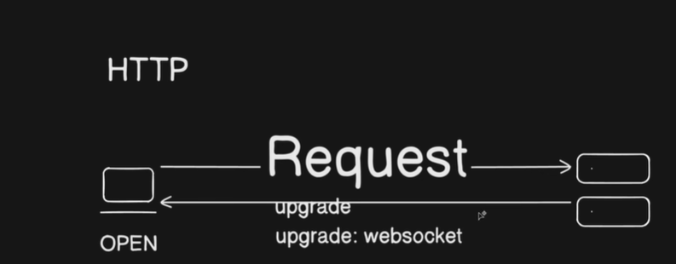

Step 1: TCP Connection
Before anything else, a TCP connection is established.
Client ---------------- Server
TCP
TCP performs the 3-way handshake:
Client Server
SYN ----------->
<-------- SYN-ACK
ACK ----------->
Now a reliable connection exists.

Step 2: HTTP Upgrade Request
The client initially sends a normal HTTP request:
GET /ws HTTP/1.1
Upgrade: websocket
Connection: Upgrade
Meaning:
"I want to switch from HTTP to WebSocket."

Step 3: Server Accepts Upgrade
Server responds:
HTTP/1.1 101 Switching Protocols
Upgrade: websocket
Connection: Upgrade
Meaning:
"Okay, let's use WebSocket."
At this point:
HTTP ends
WebSocket begins
The same TCP connection remains open.

Step 4: Persistent Connection
Instead of:
Request
Response
Connection Closed
we now have:
Client <===============> Server
A single long-lived connection.

Step 5: Two-Way Communication
Both sides can send data anytime.
Client ---> Server
Server ---> Client
Client ---> Server
Server ---> Client
This is called:

Full Duplex Communication
Unlike HTTP, the server doesn't need to wait for a request before sending data.

